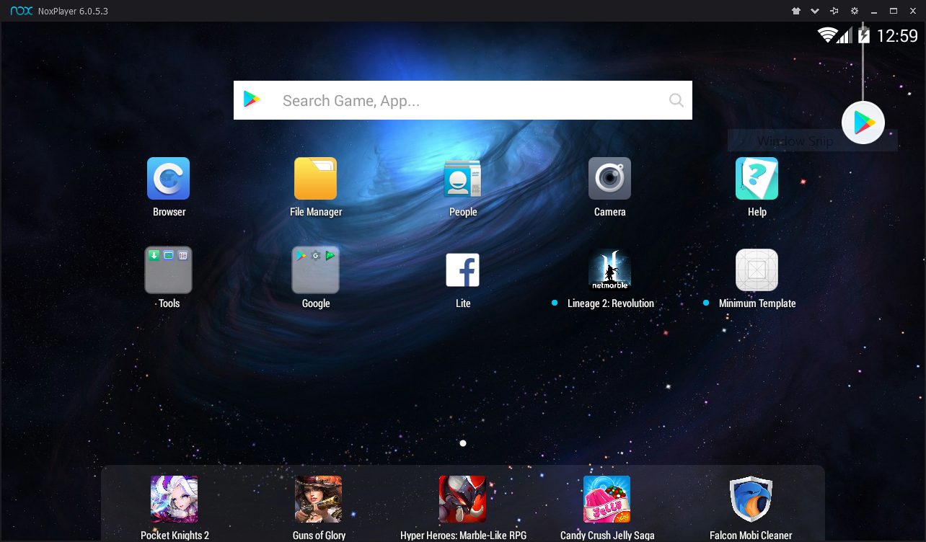

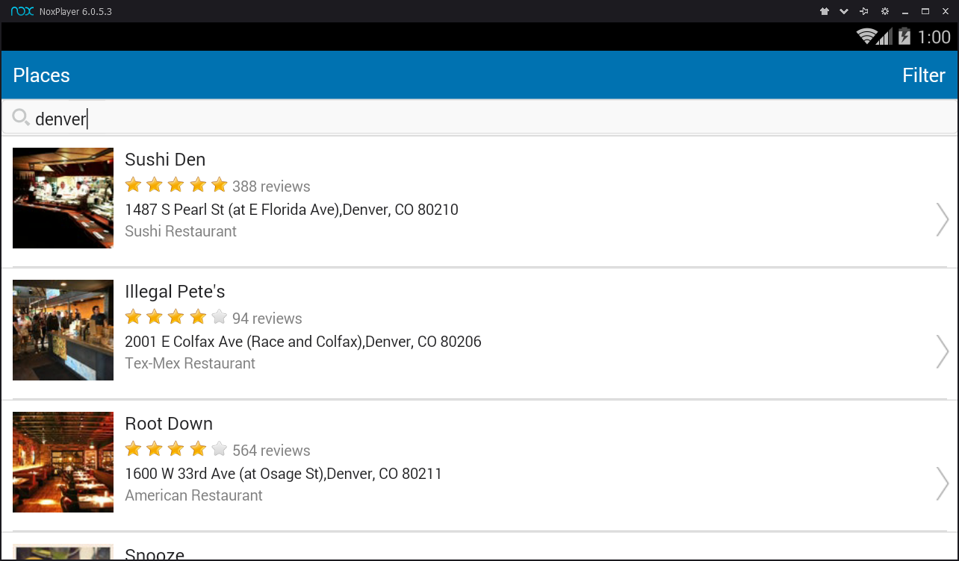

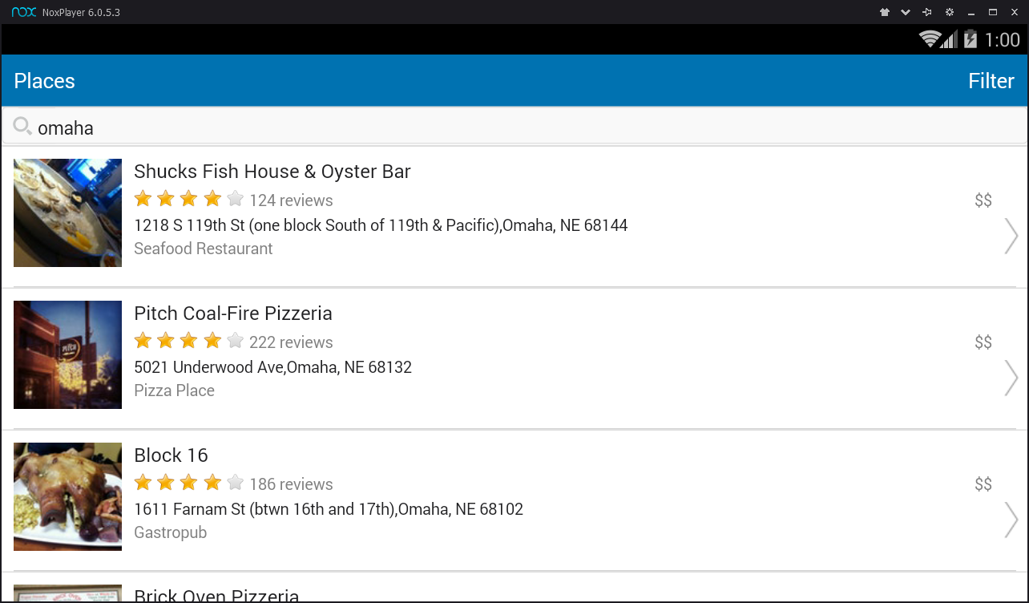

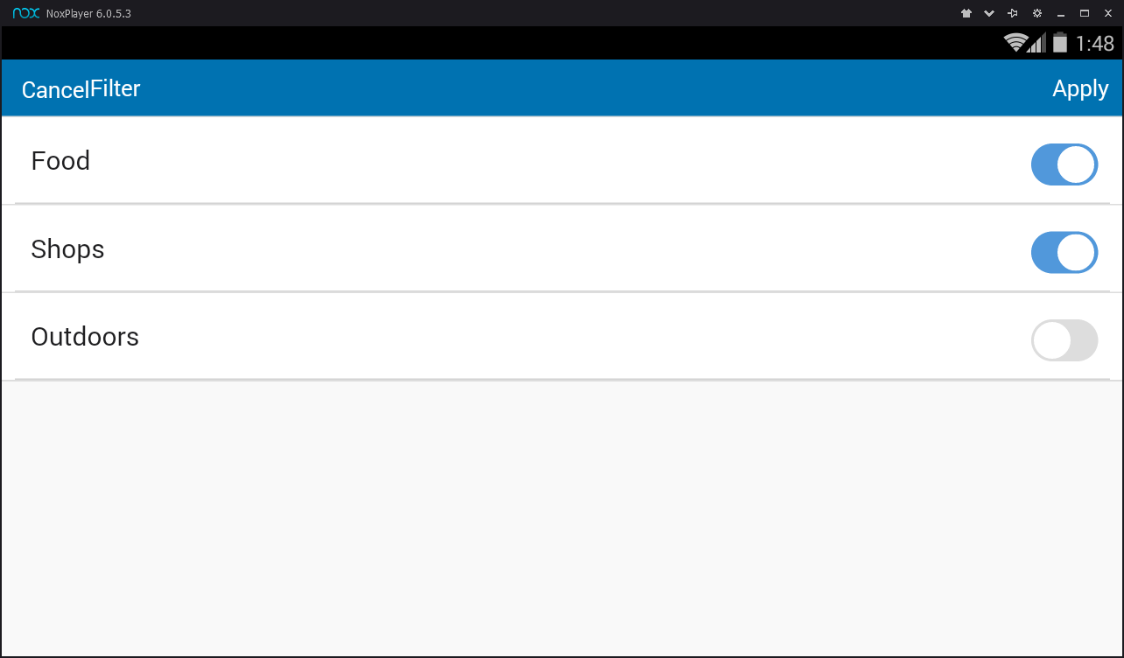

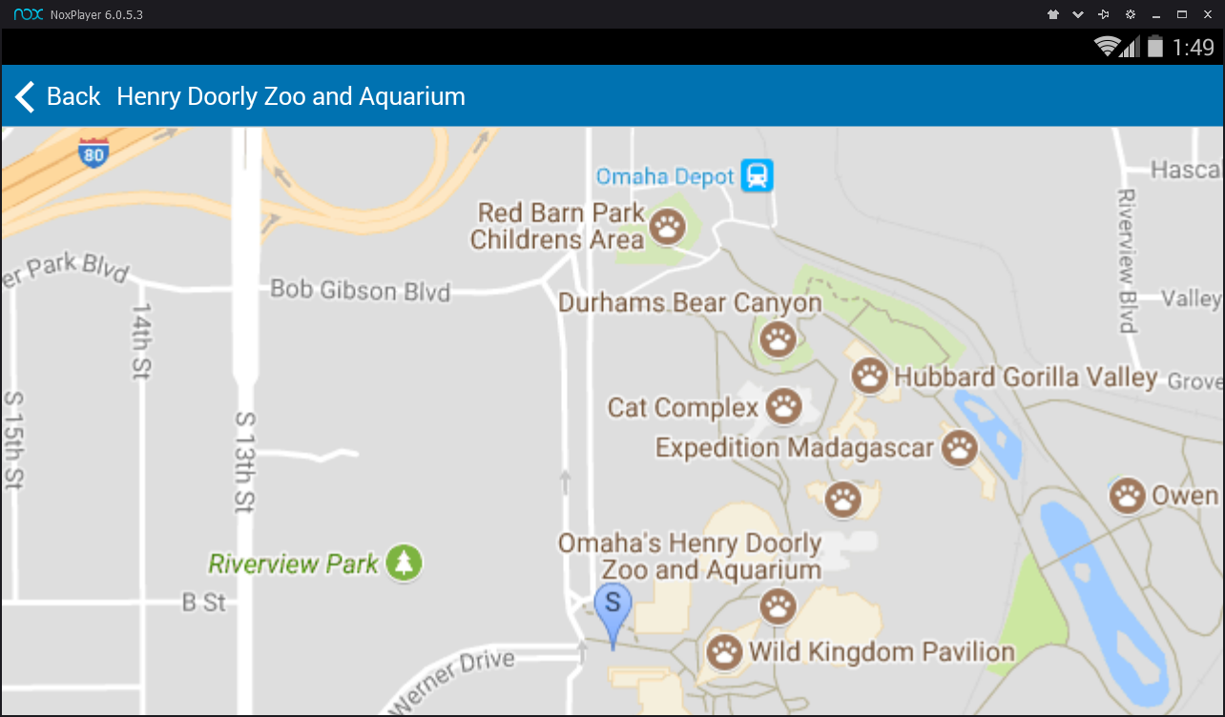

Answers:

1. When should you consider using hybrid mobile application like Cordova/Monaca versus building native applications? What are the advantages and disadvantages of using tools and development environments like Cordova/Monaca?

Cordova/Monaca are platforms used for building hybrid mobile applications. Hybrid apps combine and embed the HTML/JavaScript into a thin native mobile app layer called container. Hybrid apps bring both good and bad features from the native app platform and HTML world.

If building simple and cross platform like Android and iOS, then Hybrid is better.

|  |  |  |
| --- | --- | --- |
|  | **Advantages** | **Disadvantage** |
| 1 | Open source , free | UI framework is required |
| 2 | No need to learn Native language like C or Java. | Debugging is tricky |
| 3 | Same code for Android, iOS, Windows APP | Needs plugins |

2. When should you consider using hybrid mobile application like Cordova/Monaca versus A mobile friendly web application? What are the advantages and disadvantages of using tools and development environments like Cordova/Monaca?

Using cordova/monaca we could build apps for android, iOS, windows. But these apps are platform dependent.

A mobile friendly web application would be available to open from any browser. Meaning these mobile apps are browser dependent. Just we need to test them on all browsers to make is comportibile.

Both have same data communication protocol, JSON over HTTPS i.e., RESTful web services.

**CORDOVA/ Monaca**

|  |  |  |
| --- | --- | --- |
|  | Advantages | Disadvantage |
|  | Browser independent | OS dependent |
|  | Faster due to dedicated RAM/ memory | Uses browser resources, could be slow |
|  | More secure, could avoid JavaScript attacks/browser attacks | Special installation required |
|  | No internet needed sometimes, example: Dictionary, calculator app, etc | Takes up huge memory for every app |

3. What are the security implications of using a Hybrid mobile app environment versus building a native application?

Hybrid apps use HTML5 for webviews. So, they are technically same as mobile web app. Hence, they inherit all the vulnerabilities that exist in HTML world. Some popular attacks are XSS(Cross site scripting), malicious code injects.

Source:<https://www.teskalabs.com/blog/html5-mobile-apps-application-security>

4. What are two or three things you learned from this assignment?

* Building Hybrid apps
* Generation of API keys and usage
* Testing the android app using emulator

5. Based on the objectives of the assignment outlined above, how could this assignment be improved?

Assignment is interesting to me. This is my first time I tried building a mobile app. I would like learning more about the framework like Cordova, Angular/React used for building hybrid apps.